The following is the pre-code planning for a simple program that averages 5 grades, and displays the result as well as whether or not the student passed.

The flowchart is as follows:

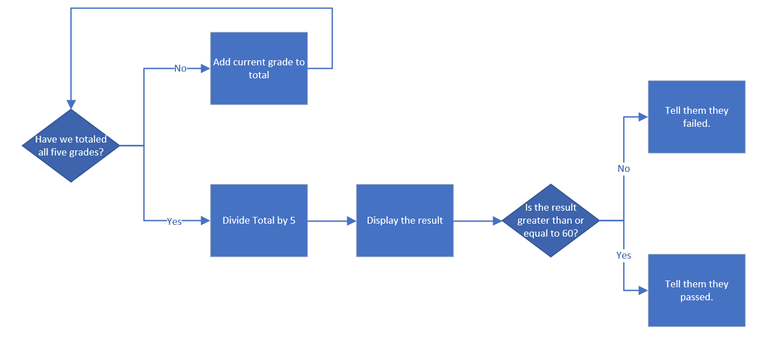

The pseudo-code is as follows:

gradeAverage{

int GradeTotal = 0;

int CurrentGrade;

float gradeAverage = 0;

int Grade1 = 23;

int Grade2 = 87;

int Grade3 = 93;

int Grade4 = 29;

int Grade5 = 90;

for (CurrentGrade is equal to or less than five) {

add the current grade to the grade total and loop back.

increment CurrentGrade to keep track of loop position.

}

display the average grade.

if the average grade is above or equals to 60,

then tell them they passed.

else,

then tell them they failed.

}